LAB-3 REPORT

I have created a html file and java script file for my local database storage. In this I have added some of the text fiels like

* Enter your name
* Enter your age
* Enter your favourite colour

And I have also added two buttons

* Save button: It save the data which are entered in the above text field boxes
* Get Data button: it retrieves the saved data which is stored in the local database

So this helps for storing and retrieving our data which helps for futhur use. There are many advantages by this.

This is the result page shown in JSFiddle

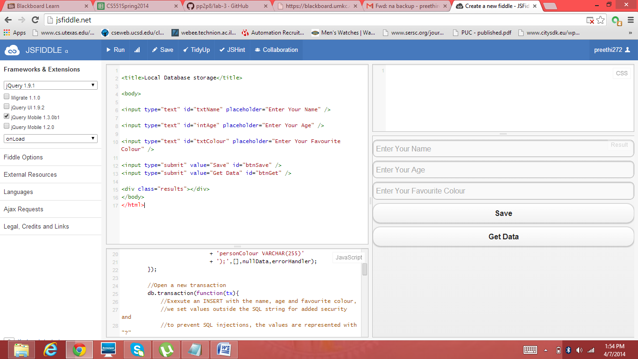

Now I have opened the opera mobile emulator and below is the screen shot for the local database storage page.

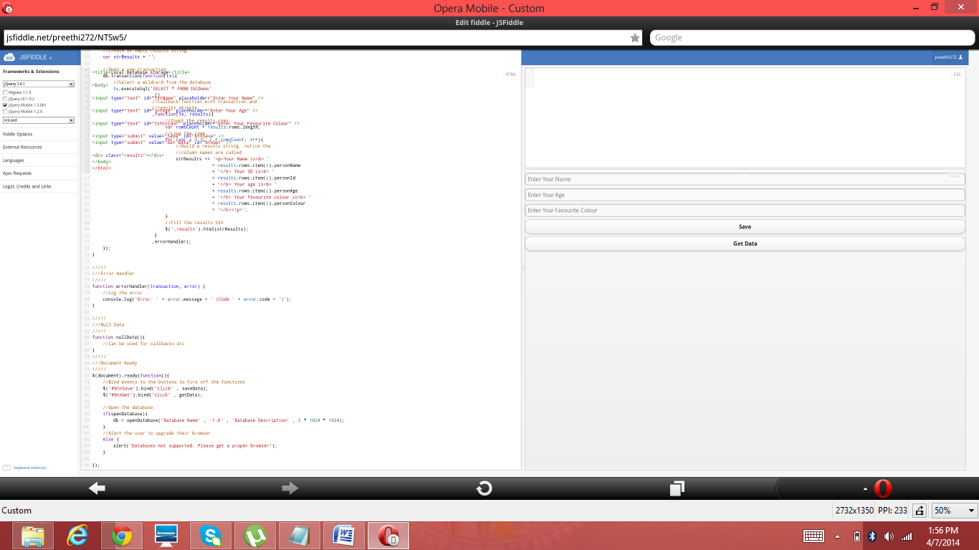

I have entered the details and clicked on the save button.

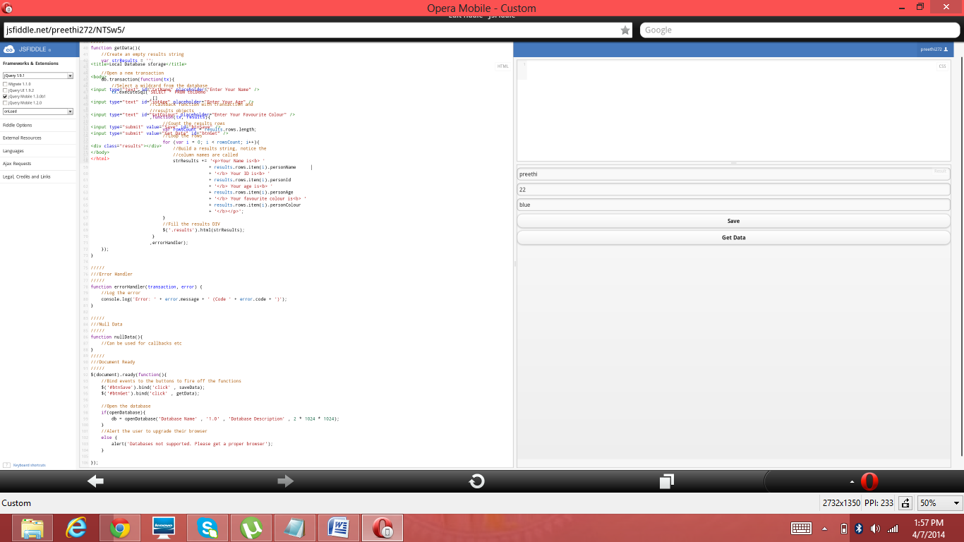

After saving the details I have clicked on the Get Details button and I got the information which is entered and here is the screen shot of how it looks.

